COMMUNITY IMPACT LETTER OF INTENT 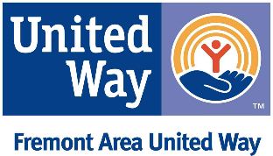 INSTRUCTIONS
2023 Funding Cycle

Organizations that want to seek funding from Fremont Area United Way for the 2023 Community Impact funding cycle, must submit a Letter of Intent prior to completing the Community Impact Funding Application. Letters of Intent must include the following information:

- Organization Description – What is your mission statement? How is your organization structured?

- Please let us know if you can provide all of the information requested in the full Funding Application document? (At this time in your Letter of Intent state YES or NO regarding if these items will or will not be provided in the full application):

    - Board and administrative information
    - Proof of 501c3 status
    - Current bylaws
    - Annual operating budget (for the entire organization)
    - Confirmation that yearly audit occurs or yearly financial review occurs for your organization. Or confirmation that your fiscal agent has a yearly audit or fiscal review.

- Program Description – Describe the program for which you are seeking funds. How is it delivered? What outcomes will you measure, and how will you measure them?

- Proposed Funding Request – What amount of funding do you plan to ask for? What is your rationale or justification for the amount? What priority area(s)?

- Service Scope - Approximately how many unduplicated people do you predict the program will
serve in 2023? Geographic area(s) that this request will cover.

Letters of Intent are due by 5:00 pm on Friday, September 30, 2022. Late submissions will not be considered. Please email your letter to Christy Fiala at christy@fremontunitedway.org. Organizations will receive responses by Friday, October 7, 2022.

